March 13, 2014

RE: Type of Loan: Conv FHA VA RD ___Other
Loan Amount: $
Approx Value: $
Loan Term: ___30 Yr. Fix ____15 Yr. Fix ____ ARM ___ Other
Max LTV Ratio: %
Other Loan Characteristics:

Dear Mr. and Mrs. Customer:

Based on the terms and conditions listed above, this letter is to certify that you have met the requirements of the Louisiana Residential Agreement to Buy or Sell pertaining to the following:

- We have received and reviewed from each applicant a fully executed Uniform Residential Loan Application along with all Federal and State disclosures that pertain to the loan product for which you have applied.

- We have received and have reviewed a tri-merge credit report for each loan applicant.

- We have received all income documents requested including but not limited to pay stubs, tax returns, W-2’s and or 1099’s along with asset documentation for all financial accounts required to comply with basic underwriting guidelines.

- The appraisal has been received and reviewed.

This letter does not constitute final loan approval. Final loan approval requires (1) your financial status and credit report to remain substantially the same until the loan closes; (2) the collateral to remain the same until the loan closes including condition, clear title,
availability of insurance, and survey; (3) the described loan product to remain available in the market; and (4) your execution of the loan documents as required by the lender.

This letter is in a format approved by the Louisiana Mortgage Lenders Association and the Louisiana Real Estate Commission. The members of the Louisiana Mortgage Lenders Association using this letter strictly adhere to the code of ethics of LMLA which can be viewed at www.lmla.com.

Sincerely,

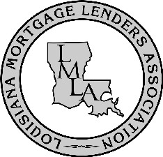

Approved LMLA Format

