March 13, 2014

RE: Type of Loan: Conv FHA VA RD ___Other
Loan Amount: $
Approx Value: $
Loan Term: ___30 Yr. Fix ____15 Yr. Fix ____ ARM ___Other
Max LTV Ratio: %
Other Loan Characteristics:

Dear Mr. and Mrs. Customer:

Thank you for giving us the opportunity to assist you in financing your new home purchase. This letter is to certify that you have made written application for a mortgage loan based on the terms and conditions listed above.

While this letter does not constitute loan approval, we are working with you to process your loan application in a timely manner. The processing of a loan file includes but is not limited to: reviewing income and asset information to discern your ability to repay, successful processing of your 4506-T form, receiving preliminary approval through an automated underwriting system, and ordering an appraisal for the property you have contracted to purchase.

This letter serves to satisfy the terms and conditions of the Louisiana Residential Agreement to Buy or Sell pertaining to making written application and is in a format approved by the Louisiana Mortgage Lenders Association and the Louisiana Real Estate Commission. The members of the Louisiana Mortgage Lenders Association using this letter strictly adhere to the code of ethics of LMLA which can be viewed at www.lmla.com.

Sincerely,

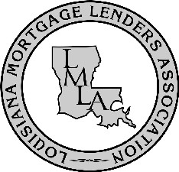
Approved LMLA Format

